**Problem Statement:**

Imagine a drunken man who, starting out leaning against a lamp post in the middle of an open space, takes a series of steps of the same length l. The direction of these steps is randomly chosen from North, South, East or West. After N steps, how far (d), generally speaking, is the man from the lamp post? Note that d is the Euclidean distance of the man from the lamp-post.

**Analysis:**

Consider the lamp post to be origin, the drunken man can move in either north, south, east or west with each direction having equal probability of being chosen.

Here, N,d and l have been varied and their values have been tested for 10 iterations of experiment for the same values and their final values have been recorded.

**Part A:**

Consider the step size, l to be constant of unit length.

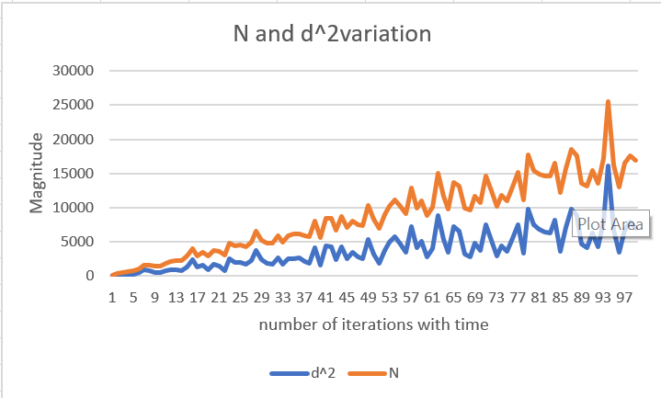

Here, we observe that as the iterations increases linearly with time, the Euclidean distance d also increases. And, N = d2 and l =1

The result can be viewed in detail in file Analysis_with_constant_step_size_parta.csv

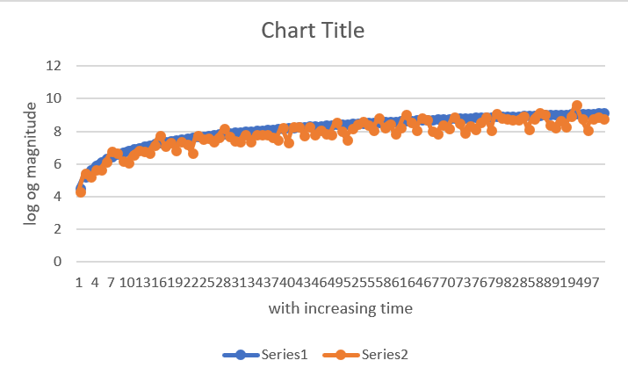

Here, series1 is 2 log d and series 2 is N which are almost equal in most cases.

**Part B:**

Vary the step size and compute the distance.

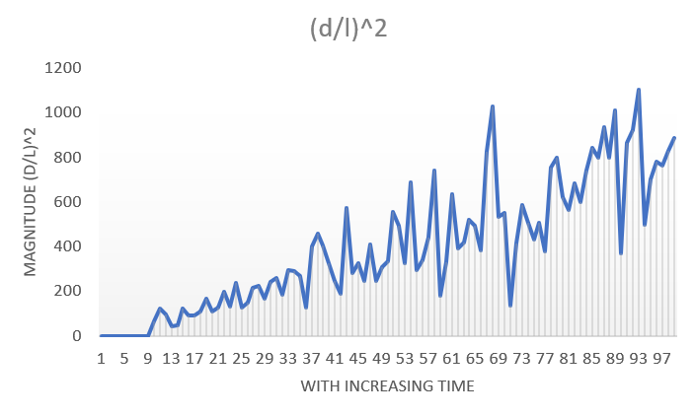

The result can be viewed in detail in file Analysis_with_varying_step_size_partb.csv

Here, we observe that as time increases, N = (D/L)2

**Verification of result obtained:**

The experiment was conducted for different step size varying from 1 to 9, and results obtained were analyzed further.

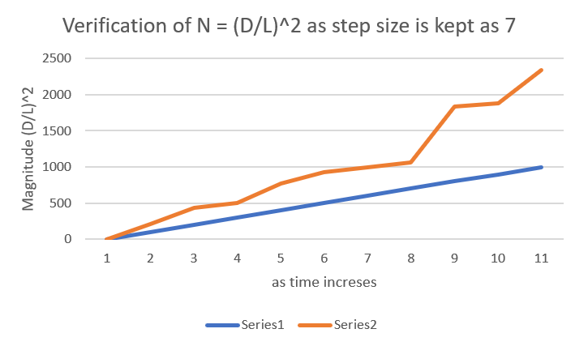

Here, series 1 is the number of steps and series 2 is the magnitude of (D/L)2

The result can be viewed in detail in file Analysis_with_varying_step_size_verification.csv

Again, we observe that as time increases, N = (D/L)2

Though the graph shown above is for step size taken as 7, similar trend was observed for all step sizes from 1 to 9.

Hence, for a random walk, the relationship between N, l and d is:

**N = (D/L)2**